National College of Computer Studies
Paknajol, Kathmandu

Report on DriveEase
A Car Rental System
Submitted by: | Submitted to:
Anshu Hada | Yachu Shakya
BSc.CSIT 5th Sem

Section: A
Submission Date: April 30, 2026

Contents
Abstract i
1. Introduction 1
2. Problem Statement 2
3. Objectives 3
4. System Architecture & File Structure 4
5. Database Design 5
6. Key Features & Modules 6
7. Screenshot of the Application 7-8
8. Conclusion 9
9. Future Implementation 10
10. References 11

Abstract

The Car Rental System is a web-based application developed to modernize and automate the traditional process of renting vehicles. This system provides an efficient platform where customers can easily search, view, and book available cars based on their preferences, while administrators can manage vehicle records, customer information, and rental transactions in a centralized system.
The application is built using web technologies such as HTML, CSS, JavaScript, and PHP, with a MySQL database for secure data storage and management. It eliminates the need for manual paperwork and reduces errors associated with traditional rental systems. Customers can register, log in, browse different categories of cars, check availability, and make bookings conveniently from anywhere.
On the administrative side, the system offers functionalities such as adding new cars, updating vehicle details, managing bookings, and monitoring customer activities. The system ensures accurate record-keeping, improves operational efficiency, and enhances the overall user experience.
By automating the rental process, the Car Rental System saves time, reduces human effort, and increases reliability.

Introduction

The DriveEase Car Rental System is a web-based application developed to automate and simplify the process of renting vehicles. It provides a centralized platform where customers can easily interact with the system to search for available cars, make bookings, complete payments, and manage their rental activities. At the same time, administrators are provided with powerful tools to manage cars, users, and rental operations efficiently.
In traditional car rental systems, most tasks such as booking, record-keeping, and tracking vehicle availability are handled manually or through disconnected systems. This often leads to errors, delays, and difficulties in managing large volumes of data. Customers may face inconvenience in checking car availability or managing their bookings, while administrators may struggle with tracking issued and returned vehicles, handling overdue rentals, and maintaining accurate records.
The DriveEase system addresses these challenges by offering a fully integrated solution. Customers can register or log in, search available cars, make bookings, perform payments, view booking history, and cancel reservations when needed. On the other hand, administrators can issue cars, receive returned vehicles, manage car and user data, generate reports, monitor overdue rentals, apply charges, and update return status.
Overall, the DriveEase Car Rental System provides a reliable, scalable, and user-friendly solution that benefits both customers and administrators while meeting the growing demands of modern car rental services.

2. Problem Statement

Traditional car rental systems often rely on manual processes or basic digital tools that are not fully integrated. These methods make it difficult to manage customer bookings, track vehicle availability, and handle rental operations efficiently. Customers may face issues such as limited access to real-time car availability, difficulty in booking or canceling reservations, and lack of transparency in payment and booking history.
On the administrative side, managing car inventory, issuing and receiving vehicles, monitoring overdue rentals, and maintaining customer records becomes time-consuming and prone to errors. Without a proper system, tracking overdue rentals and applying charges accurately is challenging, which can lead to financial losses and poor service management.
Furthermore, generating reports and maintaining organized data for decision-making is difficult in a manual or semi-automated environment. These limitations highlight the need for a centralized and automated Car Rental System that can efficiently handle both customer interactions and administrative operations, ensuring accuracy, reliability, and improved user experience.

3. Objectives

The main objective of the DriveEase Car Rental System is to develop an efficient and user-friendly platform that automates the entire car rental process for both customers and administrators.
Objectives:
- User Authentication – Enable customers to register and log in securely to access the system.
- Car Search and Availability – Allow users to search and view available cars and in real-time.
- Online Booking System – Provide functionality for customers to book cars easily.
- Payment Management – Allow users to make payments and ensure proper transaction handling.
- Booking Management – Enable users to view booking history and cancel bookings when needed.
- Car Issuing and Return Handling – Allow administrators to issue cars to customers and receive returned vehicles efficiently.
- Car Management – Enable admins to add, update, and delete car details.
- User Management – Allow administrators to manage customer accounts.
- Report Generation – Provide detailed reports for better decision-making.
- Overdue Rental Monitoring – Track overdue rentals and apply charges accordingly.
- Return Status Management – Allow admins to mark cars as returned and update availability.
- Centralized Data Management – Store all data securely in a structured database.

4. System Architecture & File Structure

4.1 Technology Stack
Layer | Technology | Purpose
Presentation | HTML5 | Page Structure
Presentation | CSS3 | Styling, animations, responsive layout (Grid + Flexbox)
Client Logic | JavaScript | DOM manipulation, AJAX calls, modal management, live search
Server Logic | PHP | Backend processing
Database | MySQL | Relational data storage for menu, orders, reservations, users

4.2 Project File Structure
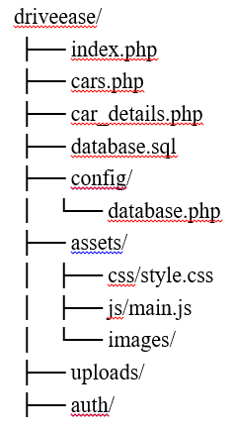
The project is organized into separate modules for clarity and maintainability:
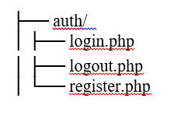
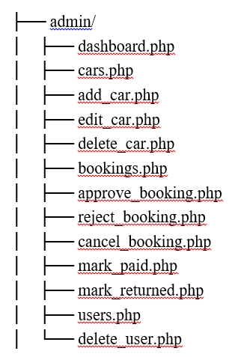

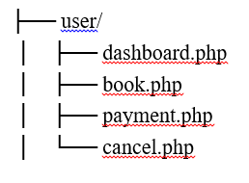

5. Database Design using Use Case Diagram
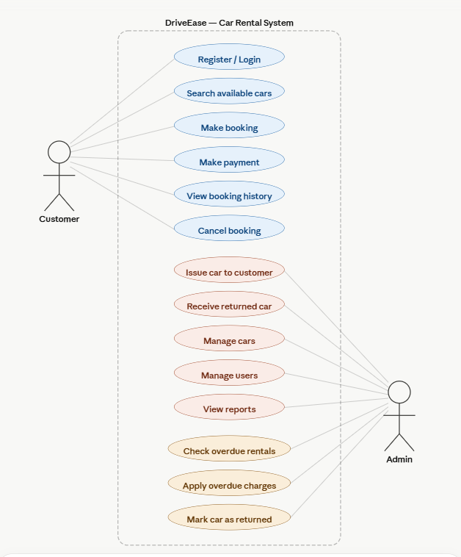

6. Key Features & Modules

- Car Browsing:
The system provides a complete listing of available cars with detailed information such as model, price per day, availability status, and images. Users can easily browse through different cars and select the one that best fits their needs.

- Booking System:
The booking system is one of the core functionalities of DriveEase. Customers can select a car and proceed with booking by choosing rental dates and confirming availability.
Once the booking request is submitted, the system records the booking details in the database and assigns a status such as pending, approved, or rejected. The admin has the authority to approve or reject booking requests based on availability and conditions.

- Payment Module:
After a booking is confirmed, users can proceed to the payment section to complete the transaction. The system allows users to mark payments and ensures that payment status is properly updated in the database.
The admin also has control over payment verification through features such as mark as paid. This ensures transparency and accountability in the system.

- Booking Management:
The system provides users with the ability to manage their bookings efficiently. Through the user dashboard, customers can view all their current and past bookings along with their statuses.

- Admin Dashboard:
The admin dashboard acts as the control center of the DriveEase system. It provides administrators with complete access to manage all aspects of the application.

7. Screenshot of the Application

7.1 Homepage
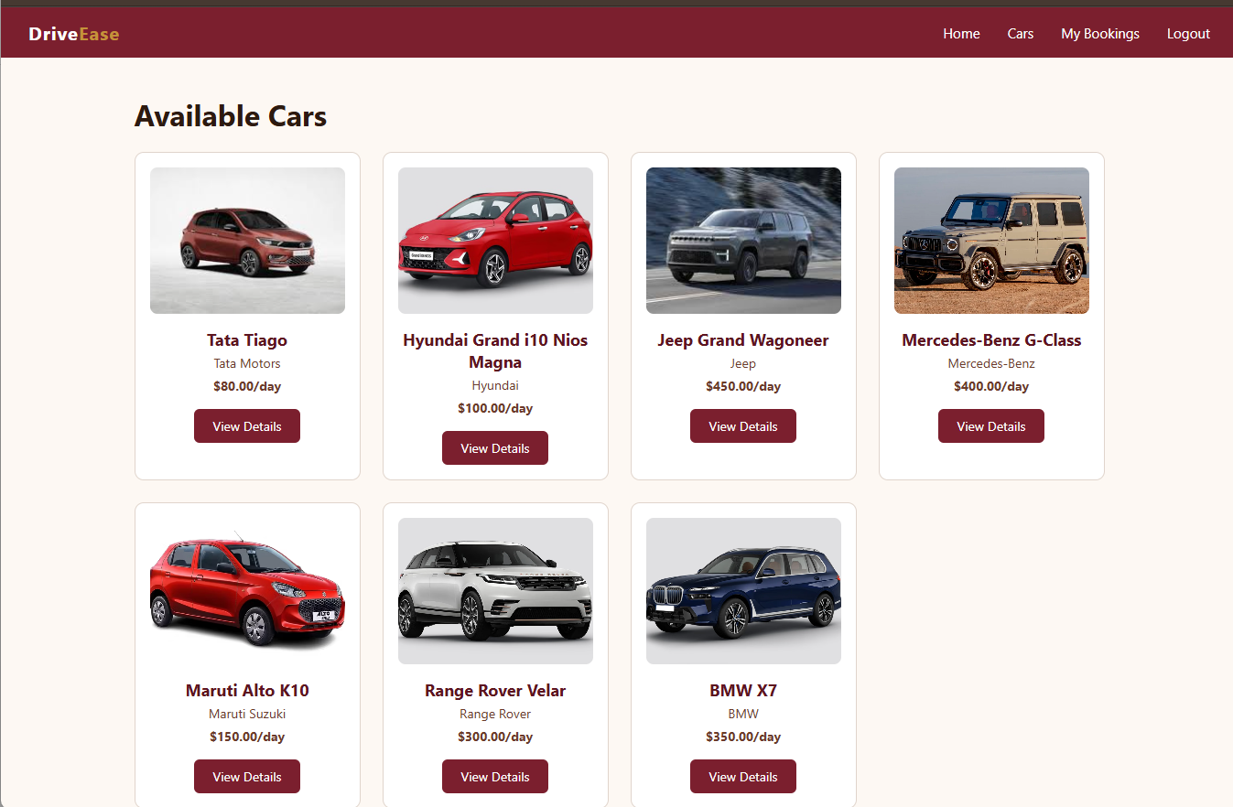

Fig: Homepage and Car Section

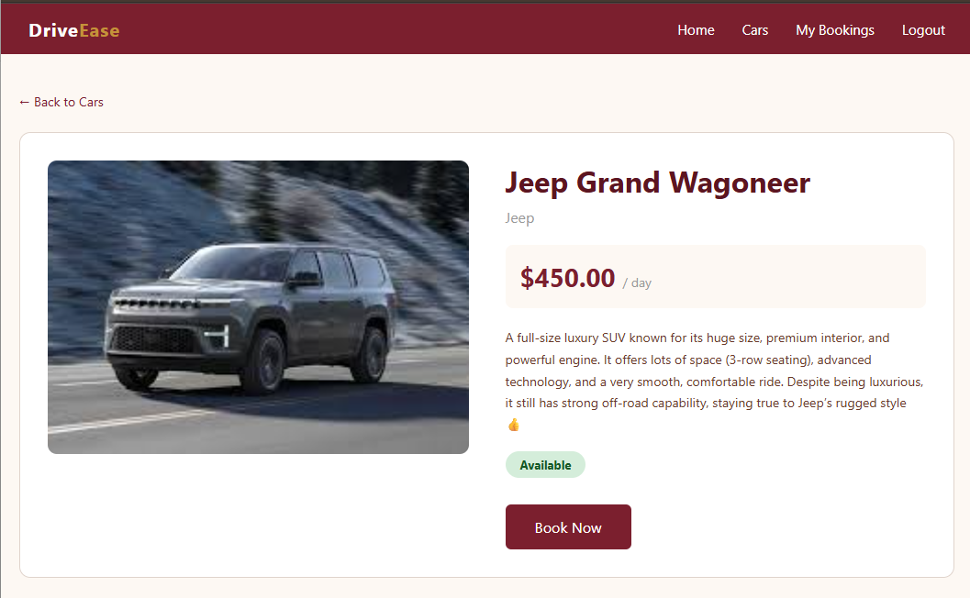
7.2 Detailed Page

Fig: Detailed Page

7.3 Admin Dashboard
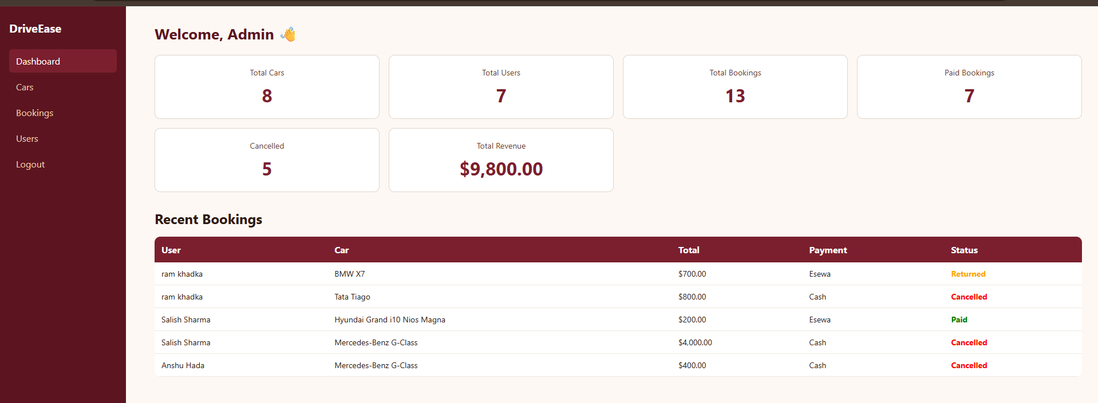

Fig: Admin Dashboard

7.4 Booking Page
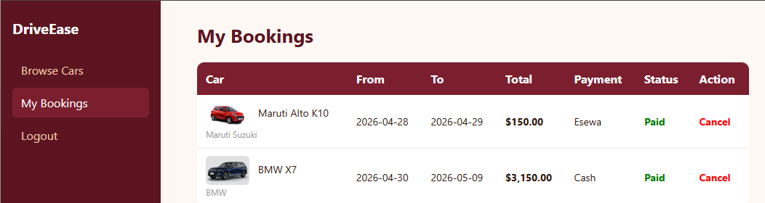
Fig: Booking Page

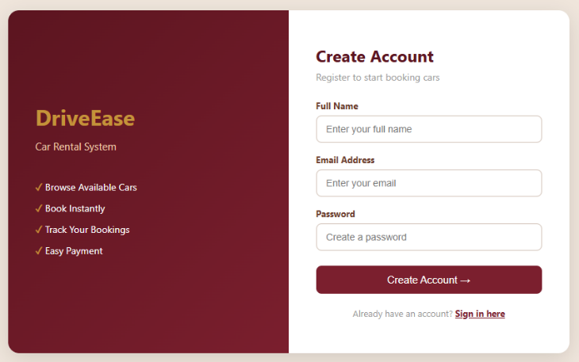
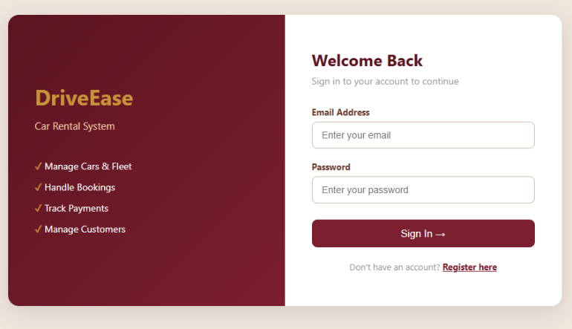
7.5 Login and Register Page
Fig: Login and Register Pages

8. Conclusion

The DriveEase Car Rental System successfully demonstrates the implementation of a complete web-based vehicle rental platform that automates and simplifies the traditional rental process. The system provides users with the ability to browse available cars, make bookings, complete payments, and manage their rental activities through an intuitive and user-friendly interface.
From the administrative perspective, the system offers full control over car inventory, user management, booking approvals, and payment tracking. This ensures efficient operation and reduces the chances of manual errors that are common in traditional rental systems.
Technically, the project showcases the practical application of core web development concepts including PHP server-side scripting, MySQL database management, session handling, and responsive frontend design using HTML, CSS, and JavaScript. The modular file structure and separation of user and admin functionalities improve maintainability and scalability of the system.
Overall, DriveEase provides a reliable, efficient, and scalable solution for modern car rental services. It enhances user convenience, improves administrative efficiency, and lays a strong foundation for future enhancements and real-world deployment.

9. Future Implementation

Although the current system meets the fundamental requirements of a car rental platform, several enhancements can be implemented to further improve functionality, performance, and user experience.
- Online Payment Integration
The system can be enhanced by integrating real-time payment gateways such as eSewa, Khalti, or international services like Stripe and PayPal. This would allow secure and instant online transactions.
- Real-Time Car Availability
Implementing real-time availability tracking would prevent double bookings and provide users with accurate, up-to-date information about car status.
- Notification System
Adding email or SMS notifications for booking confirmation, payment updates, and return reminders would improve communication between users and the system.
- Advanced Search & Filters
The system can include advanced filtering options such as price range, car type (SUV, Sedan, Electric), fuel type, and availability dates to enhance user experience.
- Rating and Review System
Users can be allowed to rate and review cars after completing rentals. This helps future customers make better decisions and improves service quality.
- GPS Tracking Integration
Integrating GPS tracking for rented vehicles would allow administrators to monitor car location and improve security.
- Penalty & Overdue System
An automated penalty system can be implemented to calculate extra charges for late returns, improving accountability and system efficiency.

10. References

• PHP Official Documentation:
Available at: https://www.php.net/docs.php
• MySQL Documentation:
Available at: https://dev.mysql.com/doc/
• JavaScript Guide:
Available at: https://developer.mozilla.org/en-US/docs/Web/JavaScript
• HTML5 & CSS3 Tutorials:
Available at: https://developer.mozilla.org

